Place these events in chronological order:
Chapter 12, Sections 2 and 4
- Beginning of the Siege of Leningrad
- Allies take Sicily
- Beginning of the Battle of Britain
- Battle of El Alamein/North Africa
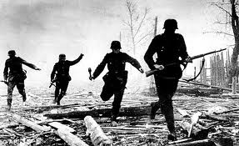
- Hitler attacks Denmark and Norway
- Lend-Lease Act
- Hitler invades Poland
- Hitler attacks the Soviet Union
- Japan attacks Pearl Harbor
- Paris falls to the Nazis
- D-Day

