Place these events in chronological order and give the date:
- D-Day

- Truman Becomes President

- VE Day
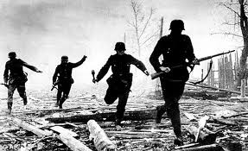
- Battle of the Bulge

- Hitler Commits Suicide

- Roosevelt Dies

- Germany’s Surrender

