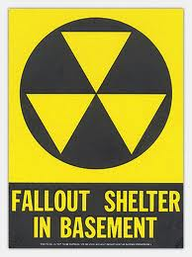
Cold War Project Name_______________
Topic: Period_____

Who
*

What
*
*
*

When
*

Where
*

Why
*
*
*
Image ( on a separate sheet of paper)

