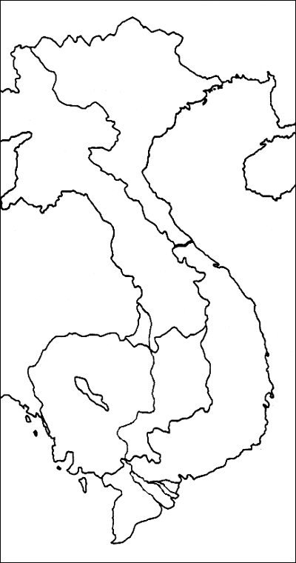
Label the following:
Countries (Multi Colors) Cities Water (Blue)
North Vietnam Thailand Hanoi South China Sea
South Vietnam Cambodia Saigon Gulf of Tonkin
China Phnom Penh Gulf of Thailand
Laos Bangkok *Draw the Ho Chi Minh Trail (Red)
Vientiane * Draw the 17th Parallel (Yellow)

